* Moore’s law: every 18 months to 2 years the number of transistors would double per unit area.
* After reaching the limit of transistor in a processor, number of processors would have to increase(parallel processing)
* Graphic processor (AMD) developed GPU in silicon valley
* Decrease in the price of a byte of data plus the high demand made cloud computing viable
* in the 1940’s Dials and punch cards were used as the first kind of GUI
* ENIAC I took a year to design and 18 months to build cost half a million dollars .
* first integrated circuit was developed by intel
* PCs were developed in late 19 century

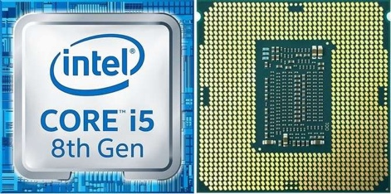

* Processors have 2,500,000,000 transistors
* ARM was recently bought for 23 billion pounds by a Japanese company SoftBank Group
* To save energy/cooling costs many data centres are built in cold climates
* Big companies like Google, Amazon etc. use their own data centres
* 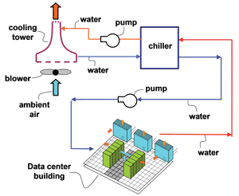
* **Server:** A high performance computer consisting between 4 and 128 processors with memory